**Foraging traits predict stage-structured feeding by freshwater fishes**

Running head: Stage-structured feeding by freshwater fishes

Abraham J. Kanz1,2 and Jeff S. Wesner1

1Department of Biology, University of South Dakota, Vermillion, South Dakota

2Present Address:

The Department of Natural Resource Ecology & Management

Oklahoma State University

474-B Agricultural Hall

Stillwater, OK 74078

Corresponding Author: [abraham.kanz@okstate.edu](mailto:abraham.kanz@okstate.edu)

Keywords: Stage-structured feeding, food webs, freshwater, aquatic insects, fish

**Abstract**

Fish are often top predators in freshwater ecosystems, yet a substantial proportion of their prey can come from non-aquatic sources such as terrestrial subsidies, the importance of which is tied to fish foraging domain and behavior. However, the same fish traits (e.g., propensity for surface feeding), may also alter how fish consume the remaining fraction of aquatic prey, such as the life-stages of aquatic insects that are eaten. This is potentially ecologically important, since aquatic insects stop feeding at later developmental stages, such as pupae and adults, and are also most susceptible to predation during this transition. We hypothesized that fish feeding domain - the vertical microhabitat used for feeding – would be associated with both the fraction of terrestrial prey consumed and the fraction of aquatic prey eaten in non-feeding life-stages. Fish diets (n = 606 diet samples from 22 fish species) were collected from two backwater and two stream sites repeatedly over two months in the summer. Fish ate similar amounts of prey, regardless of foraging domain, but differed in the fraction of terrestrial prey consumed. For fish pre-classified as surface foragers and intermediate foragers, ~12% (by dry mass) of their prey were terrestrial on average, ranging up to 44% for individual fish species. In comparison, the same fraction was only 3% for fish pre-classified as benthic foragers. Similarly, for the remaining aquatic fraction, intermediate and surface-feeding fishes ate non-consumer life-stages at a rate (5-8% of aquatic prey) that was ~5-8 times higher than for benthic fishes (~1%). These results indicate that stage-structured feeding is not only common in freshwater food webs, but also varies predictably by the foraging domain of fishes.

**Introduction**

Approximately 40% of freshwater fish species are at risk of extinction or are already extinct (Jelks et al. 2008, Darwall and Freyhoff 2016). Because of the importance of fishes in freshwater ecosystem functioning, this loss has the potential to alter the functioning of freshwater food webs (Hargrave 2009, Vanni 2010) in addition to linked riparian food webs (Baxter et al. 2005, Wesner 2012). In particular, changes in fish composition can alter the top-down control of invertebrate prey in freshwater food webs through direct prey consumption (Power et al. 1990, Nakano et al. 1999, Baxter et al. 2004). However, despite the near ubiquity of fish-insect interactions in freshwater food webs, evidence for consistent top-down control of invertebrates by fish is mixed (Matthews 1998, Dahl and Greenberg 1996, Wesner 2016).

A proposed explanation for mixed effects of fish predation is that some fishes feed more heavily on drift and/or are subsidized by terrestrial prey, thereby reducing direct consumption of benthic invertebrates (Garman 1981, Nakano et al. 1999, Baxter et al. 2004, Pusey and Arthington 2003). Propensity for drift feeding or terrestrial feeding may also be associated with fish feeding traits, such as morphological or behavioral adaptations for benthic-feeding versus feeding at the surface or middle of the water column (Dahl and Greenberg 1996, Wagner et al. 2012, Ross 2013). A complementary, but less well-studied, explanation for weak effects of some fishes is that they may also target later-developing stages of aquatic insects, such as pupae (Wagner et al. 2012, Warmbold and Wesner 2018). Such feeding may be ecologically important, because pupae and adult insects are functionally identical to terrestrial insects in the sense that both life stages have stopped feeding and are no longer consumers in aquatic food webs (Figure 1). Not only may this help to explain the consistently strong effects of fishes on emerging aquatic insects, even when effects on larval insect densities are weak (Warmbold and Wesner 2018), but it is also likely to go undetected in many diet studies. For example, isotopes change little across insect life stages (Krause et al. 2014), so it is not possible to quantify stage-specific feeding in fish diets with stable isotopes, nor is it possible if prey are only categorized taxonomically.

We refer to this type of feeding as stage-structured predation. That is, predation in which predators target different life-stages of the same prey species (De Roos et al. 2008, Miller and Rudolph 2011). While ecologists have been aware of stage-structured feeding within food webs for decades (Hardy 1924, Hutchinson 1959, Werner and Gilliam 1984, Werner 1984), it is often disregarded in classical ecological theory (Bolnick et al 2011, Violle et al 2012, Nilsson et al 2018). Yet stage-structured feeding can explain important ecological phenomena such as coexistence of predators on shared prey taxa (De Roos et al. 2008), biomass overcompensation (Miller and Rudolph 2011), and regulation of aquatic-terrestrial subsidies (Wesner 2016, Clegg et al. 2018).

The goal of this study was to quantify natural variation in terrestrial and stage-structured feeding by fishes. In particular, we measured the fraction of total prey in fish diets that was eaten either as terrestrial prey or as aquatic prey in “non-consumer” life-stages (e.g., pupae or larvae; Figure 1). We hypothesized that both fractions would be substantial, with the latter fraction (% non-consumers) increasing during periods of high insect emergence, and that both fractions would vary predictably according to fish foraging domains. Namely, we predicted that the fraction of total fish diets containing terrestrial or non-consumer prey would be lowest in benthic-feeding fish, highest in surface-feeding fish, and intermediate in fishes that feed at all levels of the water column (intermediate feeders).

**Sampling Methods**

Four sites, two backwaters and two sites within one stream, were sampled during the summer for this study. Sites were chosen to increase the breadth of fish species sampled. The backwater sites were connected to the main channel of the Missouri River. The two backwater sites were Burbank beach (latitude: 42°40'11.88"N, longitude: 96°47'22.82"W) and Gunderson backwater (latitude: 42°44'56.56"N, longitude: 96°57'12.08"W). Stream sites were at different locations along the same ephemeral stream system, a first order tributary of the Vermillion river called Spirit Mound Creek, with a width less than 3m and a depth of ~1m (fluctuating with precipitation). The stream sites were upstream (latitude: 42°52'4.29"N, longitude: 96°57'16.25"W) and downstream (latitude: 42°51'7.39"N, longitude: 96°56'39.28"W). All sites are in SE South Dakota, USA.

Weekly gut sampling of fish was conducted at each of the four study sites starting on June 6, 2019. First, fish were collected via seine net and put into a 5-gallon bucket containing fresh water. To ensure that we sampled a variety of fishes, various seining techniques were used at each site, including kick-seining for benthic fishes, seining around vegetation, short seine-hauls, and long seine-hauls. Fish were then identified and moved from the holding tank to the anesthetizing tank (a 5-gallon bucket containing water and a dilute MS-222 solution). Once the fish were immobilized by the MS-222 solution, they were measured for standard length and gut contents were extracted with gastric lavage (Kamler and Pope 2001). To do this, a garden sprayer (acting as a pump for this procedure) with an appropriately sized tube for the mouth of the fish (≥ 3.2 mm inner diameter) was fed into the gut. Water was then pumped through the gut of the fish and any dislodged stomach contents were collected in a 250 µm sieve and preserved in 95% ethanol. The fish was then placed into a recovery tank (a 5-gallon bucket containing fresh water) and monitored for recovery. Finally, all collected fish were released back into the study site. Fish sampled, number of individuals sampled, and the foraging domains of these fishes are shown in Fig. 1.

Prey items from the diet samples were identified to family or order and life stage using Merritt et al. (2008). Prey were further classified as aquatic or terrestrial (based on their larval habitat) and as either a consumer or non-consumer, indicating their trophic status in aquatic food webs. Pupae and adult stages of aquatic insects along with all terrestrial insects were classified as non-consumers, while aquatic larvae were classified as consumers.

Emergence was sampled at each site to determine stage-structured feeding varied as a function of insect emergence. During peak emergence events, the number of pupal and adult chironomids available for consumption increases. For this reason, we would expect consumption of adult and pupal chironomids to also increase. Three emergence traps were deployed at each site consisting of a 0.6m X 0.6m floating, pyramidal frame and a mesh covering (Cadmus et al. 2016). Emergence samples were collected from these in the morning twice per week, following 3-4 nights of deployment. Samples were frozen upon collection and identified to family or order using Merritt et al. (2008).

Foraging domain of fishes was assigned based on previous literature studies of each species in our dataset (Poff and Allan 1995, Ross 2013). We used three categories of foraging domain to classify fishes within this study: surface foragers, intermediate foragers, and benthic foragers. Surface foragers were fish that feed primarily at the surface or within approximately the top half of the water column. Intermediate foragers were fish that will feed approximately equally between the surface, benthos, and water column (this included piscivorous species). Benthic foragers were fish that primarily feed at or near the benthos.

**Analysis**

To determine whether the proportion of non-feeding prey in diets varied across fish foraging domains, we fit a generalized linear mixed model with prey mass per stomach (mg dry mass) as the response variable, date, fish domain, prey feeding stage (consumer/non-consumer), and prey origin (aquatic/terrestrial), and their interactions as the predictor variables, and site and fish species as random intercepts. We used a Gamma likelihood with a log link, since prey mass is a positive, continuous measure. We used this model to compare both total prey mass per fish, the proportion of prey that were terrestrial, and the proportion of prey mass that were non-consumers among fish domains.

For the model above, we used prey mass per fish, rather than prey mass per fish length (e.g., corrected for fish size), because there was no evidence that larger fish had a higher mass of prey (Figure S1). Finally, we fit similar models as above for each fish species (rather than for fish domain only). These models allowed us to estimate the fraction of terrestrial or consumer prey eaten by individual fish species, rather than just fish domains.

To determine the whether fish ate non-consumer life stages more often during periods of high insect emergence, we first modeled aquatic insect emergence (number/day/m2) as the response variable and date, site, and their interaction as the predictor variables. We used a generalized linear model with a Gamma likelihood and a log link. We then used the posterior median estimate of emergence from this model on each date at each site as the predictor variable in a second model. The second model used the raw proportion of non-consumer prey (aquatic origin only) as the response variable, median emergence, fish domain, and their interaction as the predictor variables, and site and fish species as random intercepts. Because proportions were continuous values between 0 and 1, this model had a beta likelihood with a logit-link.

Finally, we re-ran each of the models above using only the chironomid portions of prey mass or emergence (excluding the prey origin parameter, since chironomids are aquatic). This allowed us to determine whether our results were impacted by the lack of life-stage information available for some taxa in the complete dataset, since chironomids are relatively easy to differentiate by life stage (larva, pupa, adult) and hence feeding stage (larvae feed in aquatic food webs, pupae and adults do not).

Models were specified in R (version 3.4.2, Core Team R, 2017) using Bayesian inference with the *brms* package (Bürkner, 2017). Posterior distributions were generated with a Hamiltonian Monte Carlo algorithm through *rstan* (Stan Development Team, 2016). Prior distributions are described and justified (along with prior sensitivity analyses) in the Supplementary Information). All code and data can be found at: https://github.com/Abrahamkanz/stageguildms

**Results**

*Fish Sampled*

We collected a total of 606 diet samples from 22 fish species (Table 1). Creek Chub (*Semotilus atromaculatus*) was the most commonly sampled fish (n = 95 samples), followed by Johnny Darter (*Etheostoma nigrum*, n = 74), and Smallmouth Buffalo (*Ictiobus cyprinellus*, n = 73). Among foraging domains, surface feeding fishes were the most commonly sampled (n = 265), followed by benthic fishes (n = 203) and intermediate fishes (n = 138) (Table 1).

*Prey composition*

Among the 59 prey taxa in fish diets, chironomids dominated by abundance, biomass, and occurrence (Figure S2). They made up 64% of all diet items by abundance, 45% by biomass, and occurred in 438/617 fish stomachs (71%). The next most common item was Branchiopods (14% by abundance, 4% by biomass, 24% by occurrence). All other prey taxa made up less than 4% of diets by abundance, biomass or occurrence. One exception was crayfish chelipods, which made up less than 4% of abundance or occurrence, but 23% of biomass due to their large size (Figure S2). They were found in 24/617 fish stomachs. Insecta were the dominant prey class, making up 75%, 61%, and 76% of diets by abundance, biomass, and occurrence, respectively. No other prey classes (n = 11 classes) made up more than 24% in any category.

*Terrestrial and stage-structured feeding*

Fish had a similar amount of prey mass in their stomachs, regardless of foraging domain, averaging 11 ± 6 mg DM per fish (Figure 2a; posterior mean ± sd). This amount varied little between fish foraginging domains (Figure 2a) or over time (Figure 3a). However, the likely trophic impact of this feeding differed among fish foraging domains. For example, for intermediate and surface-feeding fishes, 12 ± 2% of their diets were terrestrial, with averages exceeding 20% for four species (Figure 2b). In comparison, terrestrial prey made up only 4 ± 1% for benthic-feeding fishes (Figure 2b). These differences remained for the fraction of aquatic prey eaten in non-consumer life-stages, with 5 ± 1% and 8 ± 1% of aquatic prey eaten non-consumers for intermediate and surface-feeding fishes, respectively (Figure 2c). For individual fish species, this fraction was exceeded 20% for two species (*Luxilus cornutus* and *Notropis stramineus*; Figure 2c). In contrast, for benthic fish, only 1 ± 1% (by dry mass) of prey were non-consumers, a pattern that varied little over time (Figure 3c). There was a >99% probability that non-consumer prey were more prevalent in intermediate and surface-feeding fish compared to benthic fish, supporting the hypothesis that fishes from non-benthic foraging domains eat a higher proportion of prey in non-feeding life-stages.

Patterns for intermediate and surface-feeding fishes also varied widely over time. On five collection dates, the proportion of their prey that was non-consumers exceeded 20% for intermediate and surface-feeding fishes, peaking at 30 ± 13 and 30 ± 11 in June, respectively (Figure 3c). In comparison, the proportion of non-consumer prey in benthic fish diets never exceeded 4% (Figure 3c).

When the analysis was restricted to just chironomid prey, the results were similar to those above. All fish ate a similar amount of chironomids over time (Figure 3b), averaging 9 mg DM per stomach, with 95% CrI ranging from 0.4 to 41 mg DM. Intermediate fish ate a smaller amount of chironomid mass than benthic or surface fish on average, but with strong overlap among the domains (Figure 2b). As predicted, benthic fishes consistently fed on larval stages of chironomids rather than pupae or adults. Less than 5% of chironomid mass in their diets were pupae or adults on any given date (Figure 3d). In contrast, more than 10% of chironomids in intermediate or surface fish diets were pupae or adults on average (Figure 2d). This varied widely over time, with up to 40% of chironomids eaten as larvae or pupae on some dates (Figure 3d. These patterns were similar for individual fish species (Figure S1), supporting the hypothesis of stage-structured feeding in which fish partition prey not by taxonomy per se, but by life-stage.

*Insect Emergence*

Chironomids made up ~ 93% of 16,820 emergent insects collected in emergence traps. Emergence ranged from ~0 to 350 individuals/day/m2. Contrary to our initial hypothesis, there was little evidence that fish ate more non-feeding prey stages as emergence increased. The strongest relationship between emergence and proportion of non-feeding prey in diets was for surface feeding fishes (Table 4). However, the effect was relatively small (Table 4) and the relationship was noisy (Figure 4). It also disappeared when the analysis was repeated with only chironomids (Figure 4). No other fish domain showed evidence of relationship between emergence abundance and stage-structured feeding (Figure 4).

**Discussion**

This study provides empirical evidence that stage-structured feeding among freshwater fishes is predictable based on the foraging traits of the fish. As expected, fishes in the surface and the intermediate foraging domains consistently ate a higher fraction of terrestrial prey than fishes in the benthic foraging domain. However, the most important result was that fishes in those domains also differed in how they consumed the remaining fraction of aquatic prey. Namely, fishes in the surface and water-column domain fed more heavily on non-consumer prey stages (e.g., pupal and adult chironomids) than fishes in the benthic domain. While it is not surprising that benthic fishes ate more larval chironomids than other fishes, our results provide among the first quantifications of this feeding among fish foraging domains.

The potential importance of stage-structured feeding by fishes comes from several lines of evidence. First, fishes that eat a larger fraction of pupal/adult versus larval insects tend to have weak top-down effects on benthic macroinvertebrates, but strongly reduce the emergence of adult aquatic insects (Wesner 2010, Warmbold and Wesner 2018). For example, Green Sunfish (*Lepomis cyanellus*) and Smallmouth Buffalo both reduced emergence of adult aquatic insects by ~50% but had different top-down effects on the larval, benthic forms of those insects, despite eating similar amounts of prey. The explanation for these differences was that Green Sunfish ate a larger fraction of chironomids as pupae/adults (~12-50%) compared to benthic-feeding Smallmouth Buffalo (*Ictiobus bubalus*; <5%). Both types of feeding reduced insect emergence, but only Smallmouth Buffalo controlled benthic larval densities (Warmbold and Wesner 2018). In the current study, at least three species (*Luxilus cornutus*, *Notropis stramineus*, *Cyprinella spiloptera*)had similar diets as Green Sunfish, with at least 19% of all aquatic prey eaten in non-consumer life stages, including ~25% of chironomids eaten as pupae/adults. As a result, it seems likely that direct top-down control of larval, benthic insects in these fish communities is weakened by the consumption of pupae/adults, a prediction that would not be apparent without disaggregating the prey taxa into different life-stages (Miller and Rudolf 2011).

Second, resolving fish-insect interactions to prey life-stages reveals potentially cryptic structure in freshwater food webs. For example, without information on prey life-stages the fish domains in this study appear to have relatively similar diets, both in the amount and taxonomic make-up of their prey (e.g., mostly chironomids (Figure S2)). It is only by disaggregating the prey taxa to life-stages that differences in diet become apparent, revealing that fishes partition common prey taxa by life-stages. This is similar to previous studies that reveal “cryptic” partitioning by fish, but only when chironomids were disaggregated from family to species (Ross 2013, p 266). In that case, darters (*Etheostoma* sp.) were considered to feed opportunistically on chironomids. However, when the chironomids were identified to species, darters were revealed to be specialists on only a select number of chironomid species (Alford and Beckett 2007). In the current study, the cryptic partitioning is revealed by life-stages, rather than species, revealing an additional axis by which fish partition aquatic prey. More importantly, partitioning prey by life-stages has implications for understanding food web structure that are not apparent from taxonomic diet approaches alone. For example, Clegg et al. (2018) demonstrated that inclusion of life-stage information modifies food web structure to a greater degree than simply increasing the number of nodes through additional taxa. Instead, food webs that included life-stage information had fewer links than expected, because each life-stage node necessarily has fewer links than the full species (Clegg et al. 2018).

As predicted, stage-structured feeding was related to the foraging domain of the fishes but also varied temporally. Consumption of pupal/adult chironomids, for example, varied ~10-fold among sample dates, though it was always lowest in benthic-feeding fishes. However, the cause of this temporal variation was not clear. We expected fluctuations in stage-structured feeding to change as aquatic insects developed, changing the availability of each life stage. Yet there was no relationship between insect emergence and stage-structured feeding. One potential explanation for this is that our emergence collection was biased towards insects that were attracted to the collection bottle on emergence traps (Baxter et al. 2017). An alternative approach would have been to aspirate insects from the net in addition to collecting the bottles (Cadmus et al. 2016). We opted against this for logistical reasons and because we assumed that our method would still reflect pulses in emergence even if the total amount of emergence was not collected in the bottle.

While we were unable to definitively determine the cause behind temporal variation in stage-structured feeding, our data showed that fish foraging domain is linked to stage-structured feeding. Because the foraging traits (benthic, intermediate, surface) are generalizable to most fishes (Ross 2013), inclusion of stage-structured feeding information should improve predictions of fish resource partitioning and the flow of energy through and from aquatic ecosystems (De Roos et al. 2008, Bolnick et al 2011, Miller and Rudolph 2011, Clegg et al. 2018). For example, while we did not measure nutritional differences between insect life-stages in this study, recent work has demonstrated that insect nutritional content may vary among life-stages. Non-organic contaminants, such as metals (e.g. Zn, Pb), are lost during insect metamorphosis (Kraus et al 2014; Wesner et al. 2015). Thus, in contaminated streams it seems likely that stage-structured feeding may alter the flux of contaminants from insect to fish. Fish that feed more heavily on pupal or adult stages would receive lower exposures to some aquatic-derived contaminants than fishes that feed more heavily on larval stages (Wesner 2019). Whether these risks are consistent with the foraging strategies of fishes that we document here (i.e. benthic fishes feed more on larvae, water-column fishes feed more on pupae) depends on the behavioral flexibility of the fishes. In contaminated streams, trout switched feeding from larval aquatic to terrestrial insects, presumably because the terrestrially-derived insects had lower metal concentrations than the aquatic insects (Kraus et al. 2016). Whether a similar switch might occur among life-stages of aquatic insects in response to pollution is unknown but deserves further study.

Freshwater fish communities have changed dramatically globally due to species loss and species additions. As a result, understanding how fishes partition limited resources and control those resources is a challenge. To date, predictions of the influence of non-native fish introductions often only consider taxonomic diet overlap (Ross, S.T. 1986, Eby et al 2006, Bohn et al 2008), but it is also clear that fishes vary in their use of terrestrial resources (Pusey and Arthington 2007), and in their vertical use of the water column (Nakano et al. 1999, Wagner et al. 2012, Ross 2013). Our study adds an additional axis to the understanding of fish resource use by demonstrating that fishes also partition prey among prey life-stages. The ecological importance of this partitioning has been demonstrated for understanding the control of fishes on aquatic-terrestrial subsidies, but its importance on other aspects of aquatic food webs (e.g., species co-existence, trophic cascades) is unknown but deserves further study.

**Acknowledgments**

We thank Alexis Culley, Katy McCarthy, Sarah Lane, Jacob Ridgway, and Justin Pomeranz for help in the field and the lab. Funding was provided by NSF grants #1837233 and #1560048, and by the University of South Dakota Graduate Research and Creativity Grant. All procedures were approved by the Institutional Animal Care and Use Committee at the University of South Dakota (03-03-18-21C).

**Data Availability**

All supporting data and R script for analysis can be found at: https://github.com/Abrahamkanz/stageguildms

**Conflict of Interest**

None of the authors declare any conflict of interest.

**Literature Cited**

Bohn, T., Amundsen, P.A., & Sparrow, A. (2008). Competitive exclusion after invasion? *Biol Invasions*, 10:359-368.

Bolnick, D. I., Amarasekare, P., Araujo, M.S., Urger, R.B., Levine, J.M., Novak, M., … Vasseur, D.A. (2011). Why intraspecific trait variation matters in community ecology. *Trends in Ecology & Evolution*, 26:183–192.

Bonsall, M.B. & Holt, R.D. (2003). The effects of enrichment on the dynamics of apparent competitive interactions in stage-structured systems. *The American Naturalist*, 162(6):780-795.

[Bürkner, P.C. (2017](https://www.sciencedirect.com/science/article/pii/S2352249618300430#bbb0035)). Advanced Bayesian Multilevel Modeling with the R Package brms (2017).

Cable, L. E. (1923). Food of bullheads. *Department of Commerce: Bureau of Fisheries*, document no. 1037.

Cadmus, P., Pomeranz, J.P.F, & Kraus, J.M. (2016). Low-cost floating emergence net and bottle trap: comparison of two designs, *Journal of Freshwater Ecology*, 31(4):653-658.

Clegg, T., Ali, M., & Beckerman, A.P. (2018). The impact of intraspecific variation on food web structure. *Ecology*, 0(0):1-9.

[Core Team (2017](https://www.sciencedirect.com/science/article/pii/S2352249618300430#bbb0045)). R. Core TeamR: A Language and Environment for Statistical Computing. *R Foundation for Statistical Computing*, Vienna, Austria (2017), p. 2017

Dahl, J. (1998). Effects of a benthivorous and a drift-feeding fish on a benthic stream assemblage. *Oecologia*, *116*(3):426-432.

De Roos, A.M., Skellekens, T., Van Kooten, T., and Persson, L. (2008). Stage specific predator species help each other persist while competing for a single prey. *Proceedings of the National Academy of Sciences*, 105(37):13930-13935.

Eby, L.A., Roach, W.J., Crowder, L.B., & Stanford, J.A. (2006). Effects of stocking-up freshwater food webs. *Trends in Ecology and Evolution*, 21(10):576-584.

Fuller, P., Jacobs, G., Cannister, M., Larson, J., Makled, T.H. & Fusaro, A. (2019). *Lepomis humilis* (Girard, 1858): U.S. Geological Survey, Nonindigenous Aquatic Species Database, Gainesville, FL.

Hartvig, M. & Anderson, K.H. (2013). Coexistence of structured populations with size-based prey selection. *Theoretical Population Biology*, 89:24-33.

Herwig, B.R. & Zimmer, K.D. (2007). Population ecology and prey consumption by fathead minnows in prairie wetlands: importance of detritus and larval fish. *Ecology of Freshwater Fish*, 16:282-294.

Huryn, A.D. & Wallace, J.B. (2000). Life history and production of stream insects. *Annu. Rev. Entomol.,* 45:83– 110.

Kamler, J.F. & Pope, K.L. (2001). Nonlethal methods of examining fish gut contents. *Reviews in Fisheries Science*, 9(1):1-11.

Kraus, J. M., Schmidt, T. S., Walters, D. M., Wanty, R. B., Zuellig, R. E., & Wolf, R. E. (2014). Cross‐ecosystem impacts of stream pollution reduce resource and contaminant flux to riparian food webs. *Ecological Applications*, *24*(2), 235-243.

Kraus, J. M., Pomeranz, J. F., Todd, A. S., Walters, D. M., Schmidt, T. S., & Wanty, R. B. (2016). Aquatic pollution increases use of terrestrial prey subsidies by stream fish. *Journal of Applied Ecology*, *53*(1), 44-53.

Lancaster, J. & Downes, B.J. (2013). *Aquatic entomology*. Oxford University Press, Oxford, United Kingdom.

Merritt, R. W., Cummins, K. W., & Berg, M. B. (Eds.). (2008). *An Introduction to the Aquatic Insects of North America*. 4th edition, Kendall Hunt.

Murakami, M. & Nakano, S. (2002). Indirect effect of aquatic insect emergence on terrestrial insect population through by birds of predation. *Ecology Letters*, 5(3):333-337.

Mittelbach, G.G. & Osenberg, G.W. (1993). Stage-structured interactions in bluegill: consequences of adult resource variation. *Ecology*, 74(8):2381-2394.

Nakano, S. & Murakami, M. (2001). Reciprocal subsidies: dynamic interdependence between terrestrial and aquatic food webs. *Proceedings of the National Academy of Sciences*, 98(1):166-170.

Nico, L., Fuller, P., & Neilson, M. (2014). Cyprinella lutrensis. USGS Nonindigenous Aquatic Species Database, Gainesville, Florida.

Nilsson, K.A., Caskenette, A.L., Guill, C., Hartvig, M., & Soudijn, F.H. (2018). Including the life cycle in food webs. Cambridge University Press, *Adaptive Food Webs: Stability and Transitions of Real and Model Ecosystems* (121-145). Cambridge, UK.

Oliver, D. R. (1971). Life history of the Chironomidae. *Annual Review of Entomology*, *16*(1):211-230.

Poff, N.L. & Allan, J.D. (1995). Functional organization of stream fish assemblages in relation to hydrological variability. *Ecology*, 76(2):606-627.

Reimer, J. R., Brown, H., Beltaos-Kerr, E., & de Vries, G. (2019). Evidence of intraspecific prey switching: stage-structured predation of polar bears on ringed seals. Oecologia, 189(1):133-148.

Ross, S.T. (1982). Resource partitioning in fish assemblages: a review of field studies. *Copeia*, 1986(2):352-388.

Ross, S.T. (2013). *Ecology of North American freshwater fishes*. University of California Press, Berkeley and Los Angeles, California.

Rudolf, V.H.W. & Lafferty, K.D. (2011). Stage structure alters how complexity affects stability of ecological networks. *Ecology Letters*, 14(1):75-79.

Rudolf, V.H.W. & Rasmussen, N.L. (2013). Ontogenetic functional diversity: size structure of a keystone predator drives functioning of a complex ecosystem. *Ecology*, 94(5):1046-1056.

[Stan Development Team. (2016](https://www.sciencedirect.com/science/article/pii/S2352249618300430#bbb0145)). RStan: The R Interface to Stan. R Package Version, 2 (14) (2016), p. 1

Violle, C., Enquist, B. J., McGill, B.J., Jiang, L., Albert, C.H., Hulshof, C., Jung, V. & Messier, J. (2012). The return of the variance: intraspecific variability in community ecology. *Trends in Ecology & Evolution*, 27:244–252.

Wagner, A., Volkmann, S. & Dettinger-Klemm, P.M.A. 2012. Benthic–pelagic coupling in lake ecosystems: the key role of chironomid pupae as prey of pelagic fish. *Ecosphere* 3(2):14.

Werner, E.E. & Gilliam, J.F. (1984). The ontogenetic niche and species interactions in size-structured populations. *Annual Review of Ecology and Systematics*, 15:393-425.

Wesner, J.S. (2010). Aquatic predation alters a terrestrial prey subsidy. *Ecology*, 91(5):1435-1444.

Wesner, J.S. (2012). Predator diversity effects cascade across an ecosystem boundary. *Oikos*, 121(1):53-60.

Wesner, J. S., Walters, D. M., Schmidt, T. S., Kraus, J. M., Stricker, C. A., Clements, W. H., & Wolf, R. E. (2017). Metamorphosis affects metal concentrations and isotopic signatures in a mayfly (Baetis tricaudatus): implications for the aquatic-terrestrial transfer of metals. *Environmental Science & Technology*, *51*(4), 2438-2446.

Wesner, J. (2019). Using stage-structured food webs to assess the effects of contaminants and predators on aquatic–terrestrial linkages. *Freshwater Science*, *38*(4), 928-935.

**Figure Legends**

**Figure 1**. Conceptual figure showing different predictions for food webs without and with information on prey life-stages. Each of the food webs (a,b,c,d) has the same number and identity of prey species. a) Fish feed on a single prey consumer prey taxon (or group of consumer taxa), generating indirect effects to lower trophic levels. b) Fish target larval life stages, generating indirect effects because only larvae are consumers in aquatic food webs. c-d) Two of the life-stages (pupae and adults) do not feed. Fish that target those life stages have no indirect effects on lower trophic levels. The prevalence of this type of stage-structured feeding in aquatic food webs is unknown.

**Figure 2**. Posterior distributions, averaged across time, showing a) the total mass of aquatic prey per fish stomach, b) the total mass of chironomids per fish stomach, c) the proportion of aquatic prey eaten in a non-consumer life-stage, and d) the proportion of chironomids eaten in a non-consumer life-stage (e.g., pupae and adults). Medians and 95% credible intervals for each group are shown at the bottom of the densities.

**Figure 3**. Temporal variation in a) the total mass of aquatic prey per fish stomach, b) the total mass of chironomids per fish stomach, c) the proportion of aquatic prey eaten in a non-consumer life-stage, and d) the proportion of chironomids eaten in a non-consumer life-stage (e.g., pupae and adults) for each fish foraging domain. Boxplots summarize the median, interquartile range, and upper and lower 1.5% quantiles of posterior distributions on each date for each domain. To improve the visual distinction, 500 lines connect each date x domain group. They are drawn from 500 iterations of the posterior distribution of each group.

**Figure 4**. Relationship between insect emergence and the proportion of fish diets consisting of non-feeding prey. We expected that fish would feed most heavily on non-feeding pupal and adult prey stages during periods of high insect emergence. Contrary to expectations, there was no relationship between emergence and fish diets.

**Tables**

|  |  |  |
| --- | --- | --- |
| Table 1: Number of diet samples collected by fish species and fish foraging domain. | | |
| Fish Species | Foraging Domain | n |
| *Semotilus atromaculatus* | intermediate | 95 |
| *Etheostoma nigrum* | benthic | 74 |
| *Ictiobus cyprinellus* | surface | 73 |
| *Ameiurus melas* | benthic | 62 |
| *Lepomis macrochirus* | surface | 59 |
| *Cyprinus carpio* | benthic | 49 |
| *Cyprinella spiloptera* | surface | 47 |
| *Pimephales promelas* | surface | 30 |
| *Luxilus cornutus* | surface | 27 |
| *Lepomis cyanellus* | intermediate | 24 |
| *Ictiobus bubalus* | benthic | 14 |
| *Notropis stramineus* | surface | 11 |
| *Cyprinella lutrensis* | surface | 10 |
| *Notropis blennius* | surface | 8 |
| *Esox americanus* | intermediate | 6 |
| *Esox lucius* | intermediate | 5 |
| *Lepomis gibbosus* | benthic | 4 |
| *Lepisosteidae* | intermediate | 3 |
| *Micropterus salmoides* | intermediate | 2 |
| *Culaea inconstans* | intermediate | 1 |
| *Micropterus dolomieu* | intermediate | 1 |
| *Sander vitreus* | intermediate | 1 |

|  |  |  |  |  |  |  |
| --- | --- | --- | --- | --- | --- | --- |
| Table 2: Summaries of the posterior distribution of total aquatic prey mass per fish stomach and the proportion of non-feeding prey in fish diets by abundance. Values are averaged over 17 collection dates for each fish foraging domain and for all fish (averaged over dates and fish domain). | | | | | | |
| Response | Fish Domain | Mean | SD | 2.50% | 50% | 97.50% |
| Total aquatic prey mass (mgDM) | Benthic | 9 | 8 | 1 | 6 | 31 |
| Intermediate | 5 | 10 | 0.3 | 3 | 20 |
| Surface | 5.4 | 6.2 | 1 | 4 | 20 |
|  | All Fish | 6 | 8 | 1 | 4 | 25 |
|  |  |  |  |  |  |  |
| Proportion non-consumer aquatic prey | Benthic | 0.02 | 0.02 | 0.001 | 0.01 | 0.06 |
| Intermediate | 0.13 | 0.12 | 0.004 | 0.1 | 0.44 |
| Surface | 0.11 | 0.11 | 0.004 | 0.07 | 0.39 |
|  | All Fish | 0.08 | 0.1 | 0.002 | 0.04 | 0.38 |

|  |  |  |  |
| --- | --- | --- | --- |
| Table 3. Posterior mean and standard deviation (parentheses) of the marginal intercept and slope of the relationship between insect emergence and stage-structured feeding in fish. Values are on the odds scale. A slope of 1 indicates no change in the odds of a fish diet containing a non-feeding prey across different levels of emergence. Values below one indicates a decrease and values above one indicates an increase. Relationships were compared for each fish foraging domain in two models: Everything (all aquatic insects in emergence and diet samples) and Chironomids Only (same analysis with just chironomids). | | | |
| Model | Fish Domain | Intercept | Slope |
| Everything | benthic | 0.18 (0.04) | 1.08 (0.11) |
|  | intermediate | 0.29 (0.07) | 1.03 (0.14) |
|  | surface | 0.31 (0.06) | 1.36 (0.11) |
| Chironomids Only | benthic | 0.26 (0.06) | 1.07 (0.14) |
|  | intermediate | 0.39 (0.1) | 1.07 (0.18) |
|  | surface | 0.37 (0.07) | 1.16 (0.13) |

**Figure 1**

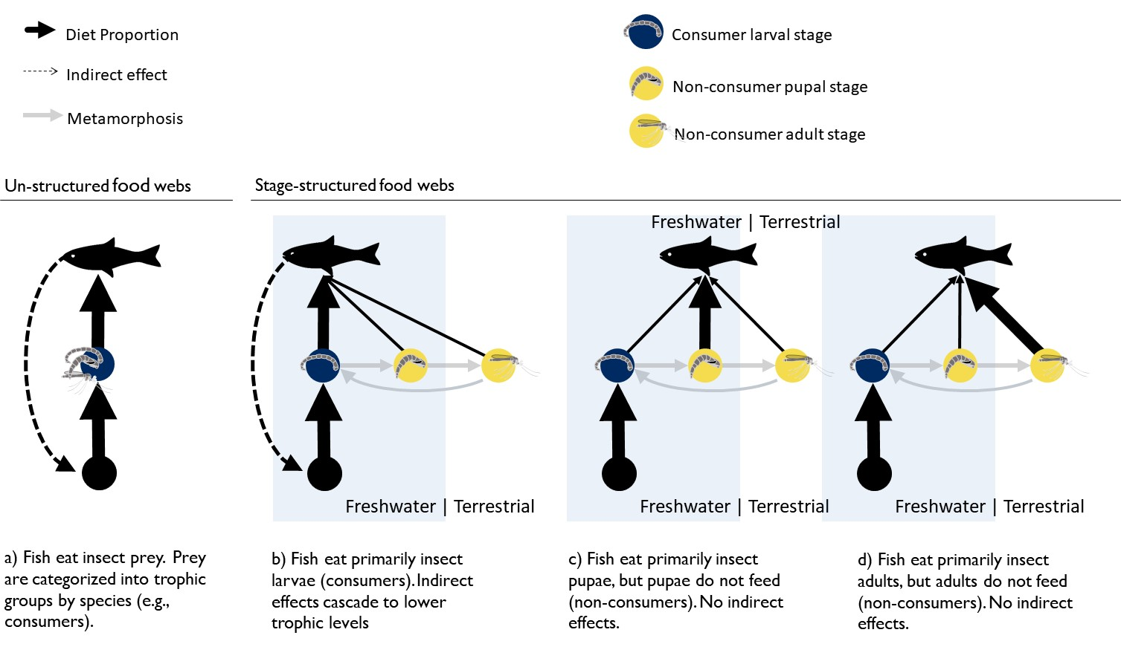

**Figure 2**

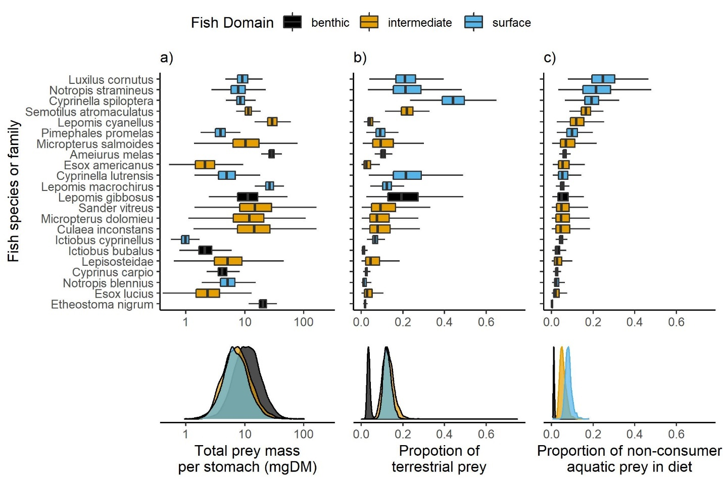

**Figure 3**

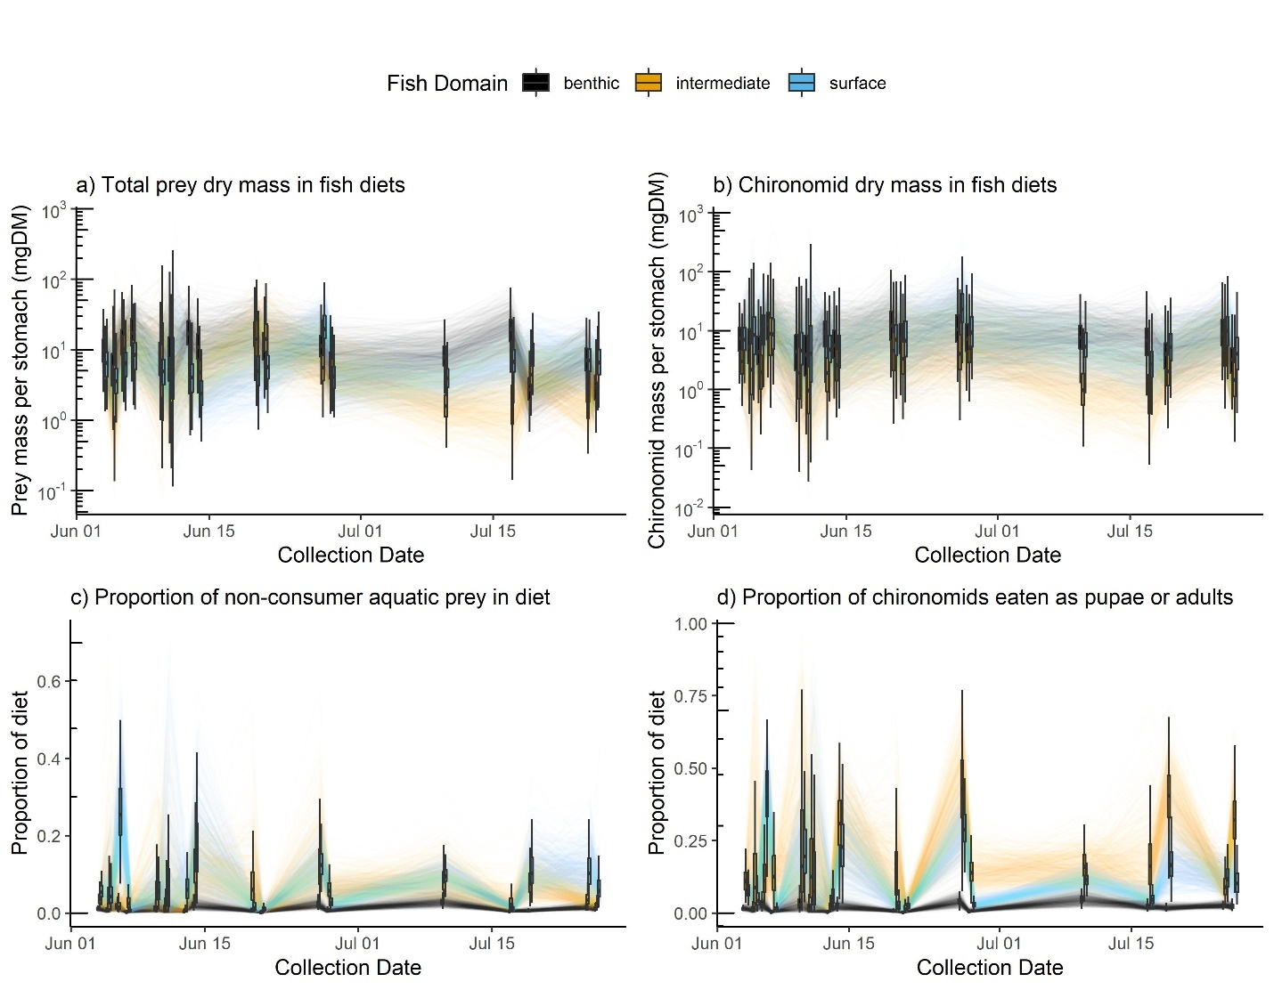

**Figure 4**

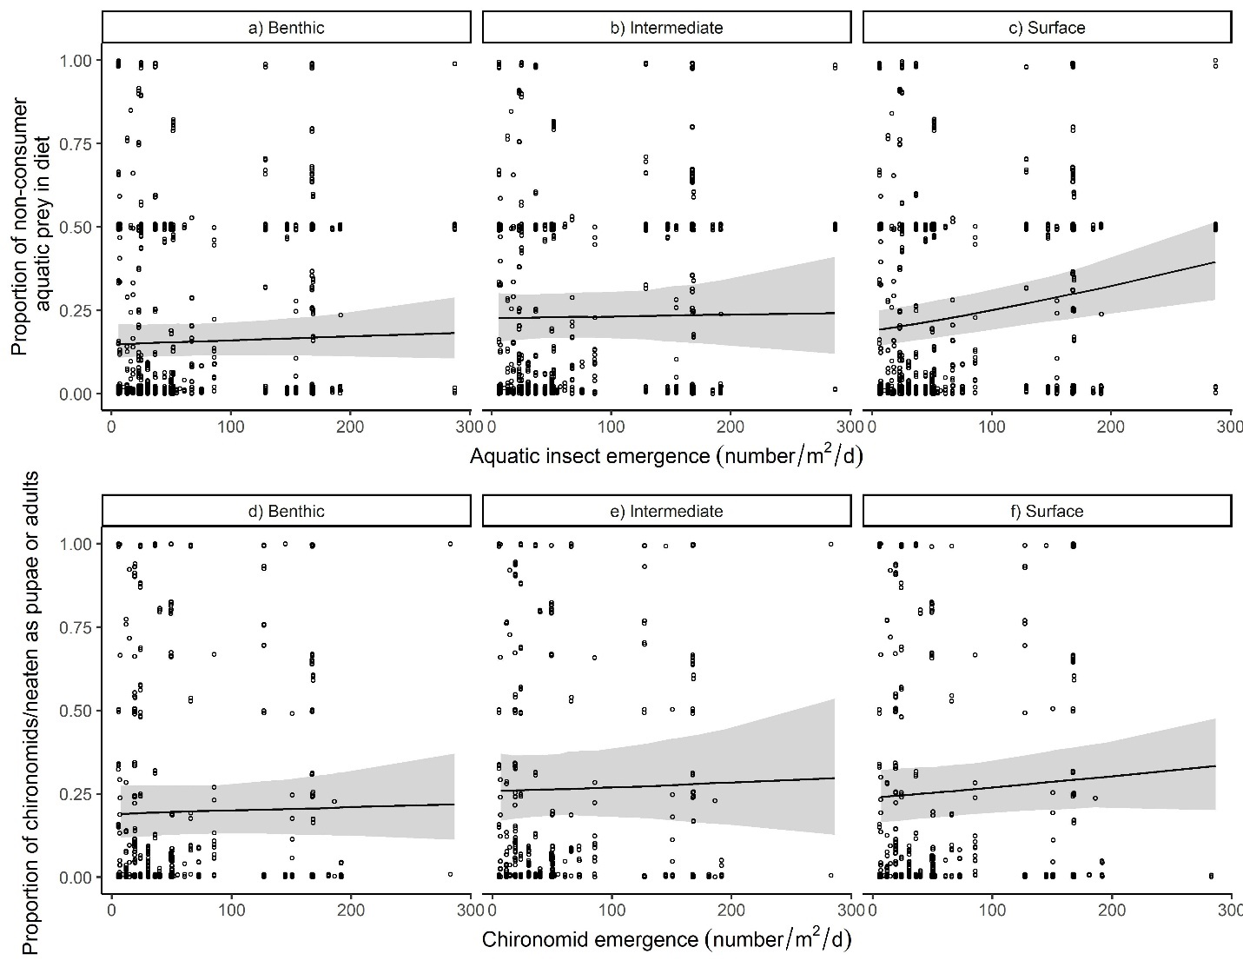

**Supplemental Information**

|  |  |  |  |  |  |  |
| --- | --- | --- | --- | --- | --- | --- |
| Table 2: Proportion of chironomid life-stages in fish diets by abundance. Values summarize the posterior distribution averaged over 17 collection events. | | | | | | |
| Prey Stage | Fish Domain | Mean | SD | 2.5% | 50% | 97.5% |
| Larvae | Benthic | 0.91 | 0.10 | 0.01 | 0.06 | 0.37 |
| Larvae | Intermediate | 0.71 | 0.17 | 0.29 | 0.74 | 0.95 |
| Larvae | Surface | 0.78 | 0.14 | 0.47 | 0.81 | 0.97 |
| Larvae | All Fish | 0.80 | 0.12 | 0.51 | 0.82 | 0.96 |
| Pupae | Benthic | 0.05 | 0.07 | 0.002 | 0.03 | 0.27 |
| Pupae | Intermediate | 0.22 | 0.15 | 0.02 | 0.20 | 0.57 |
| Pupae | Surface | 0.06 | 0.06 | 0.004 | 0.04 | 0.21 |
| Pupae | All Fish | 0.11 | 0.08 | 0.01 | 0.09 | 0.30 |
| Adults | Benthic | 0.04 | 0.05 | 0.001 | 0.02 | 0.17 |
| Adults | Intermediate | 0.08 | 0.09 | 0.003 | 0.05 | 0.34 |
| Adults | Surface | 0.16 | 0.12 | 0.02 | 0.14 | 0.44 |
| Adults | All Fish | 0.09 | 0.08 | 0.01 | 0.07 | 0.29 |

**Model Checking**

We determined prior values using prior predictive checks (Wesner and Pomeranz 2021). Briefly, we simulated the proportion of diets that were terrestrial or the proportion of aquatic diets that were non-consumers using only the prior distributions (Figure S2). We then visually compared that estimate to the posterior (Figure S2). The contrast in estimates shows both whether priors were reasonable and how much information was learned from the data. The result in Figure S2 shows reasonable but wide estimates from the prior along with narrow estimates of the posterior distribution.

In addition, we performed posterior predictive checks to determine whether and how the models mis-fit the data using the *pp_check()* function in *brms*. We compared two simulations for the two main models: 1) Model simulated means relative to data means (Figure S3a,b), and 2) histograms of model-simulated data relative to a histogram of the raw data (Figure S3c,d). Large mismatches in these comparisons indicate that the model fails to capture an aspect of the data-generating process. In general, the model simulations can recapture data summaries (Figure S3). One aspect that the models do not capture is the relatively high number of zeros in the aquatic vs terrestrial dataset. In exploratory analyses, we attempted to account for this with different likelihoods, including a hurdle gamma and by fitting the model to proportions with a zero inflated beta distribution. Neither alternative performed better in posterior predictive checks, so we chose the gamma model.

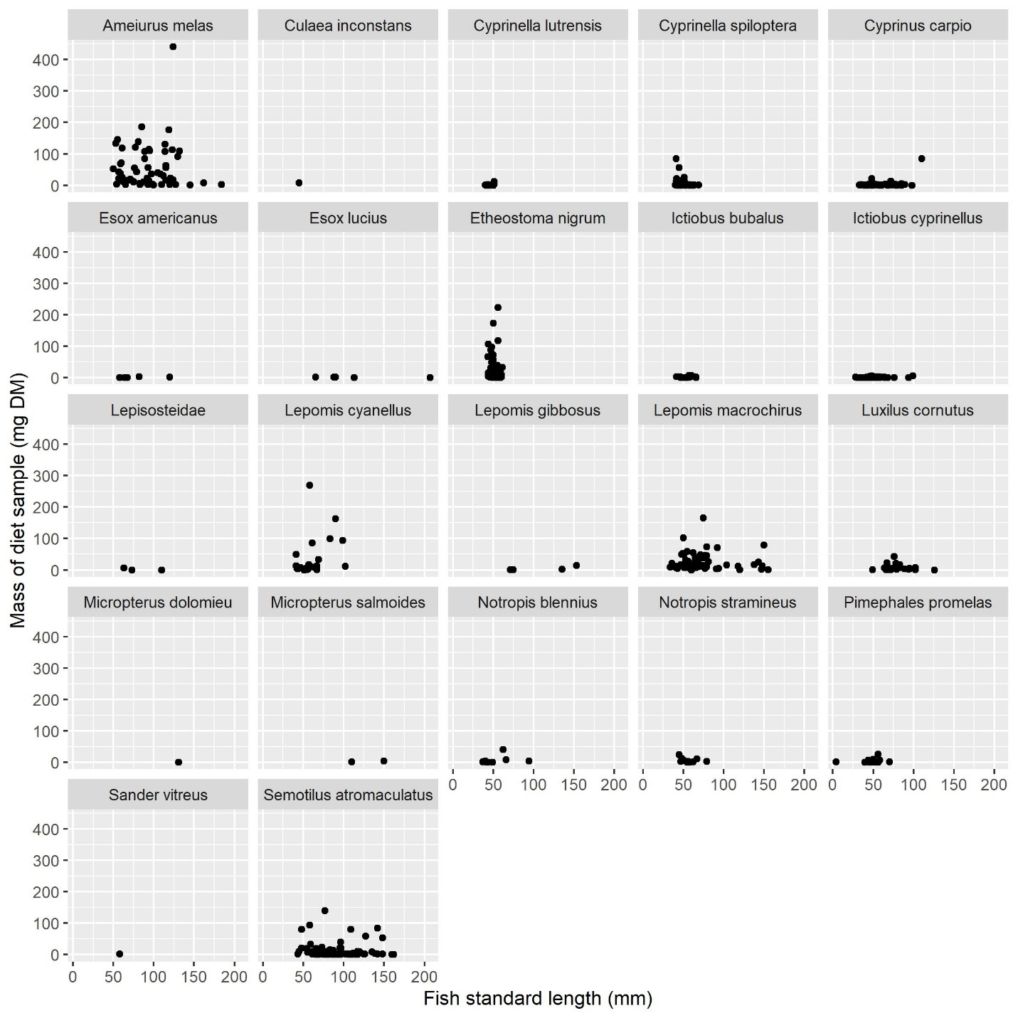

Figure S1. Plots of raw data showing no relationship between fish size (length) and the mass of prey in the diet sample. For this reason, we did not correct diet samples by fish length.

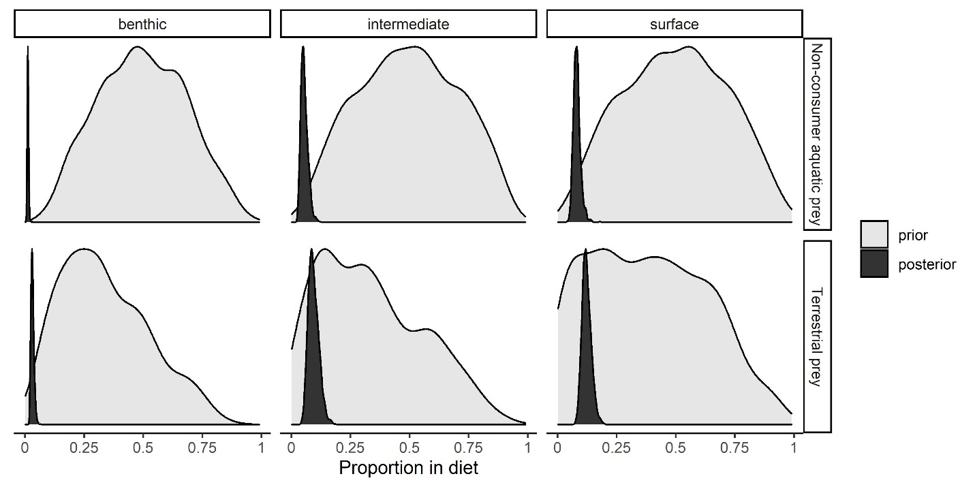

Figure S2. Comparison of the prior and posterior predictions of the proportion of aquatic prey that were non-consumers (top row) and the proportion of total prey that were terrestrial. All proportions are derived from dry mass (mg).

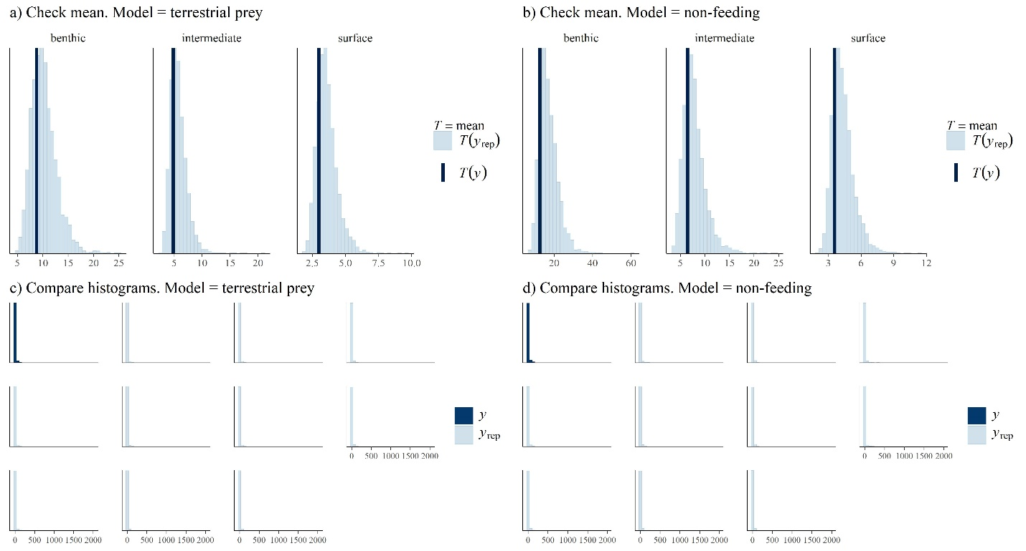

Figure S3. Checking model fits. Posterior predictive checks of models of aquatic vs terrestrial prey (“terrestrial prey”) and the proportion of aquatic prey that are non-feeding (“non-feeding”). The top panels (a,b) show each model’s prediction of mean prey mass (*T*(*yrep*)) relative to the data (*T*(*y*)). The bottom panels (c,d) compare data distributions of the raw data (*y*) relative to ten datasets simulated from the posterior distribution. Similarities in these distributions indicate that the model is a good fit.

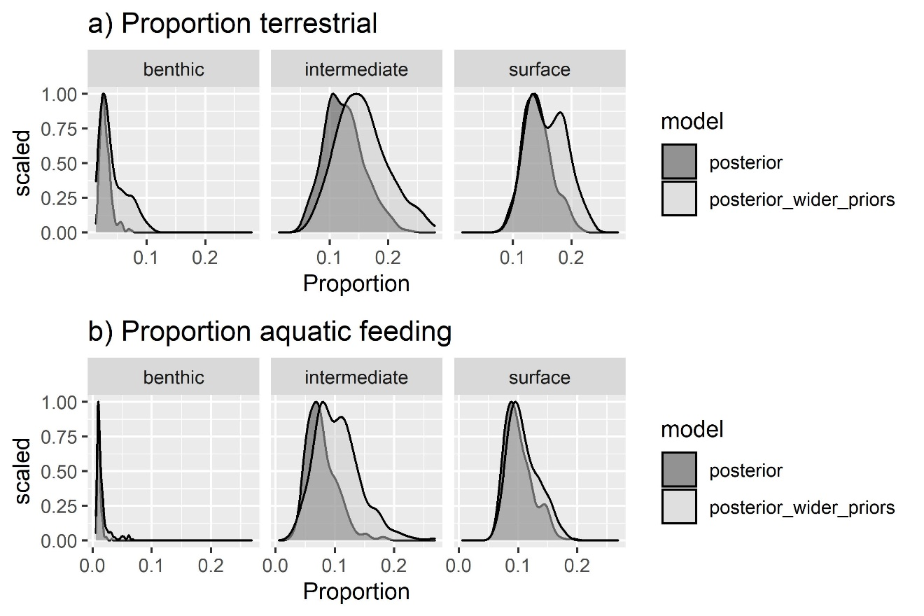

Figure S4. Prior sensitivity analysis of the proportion of terrestrial prey and the proportion of aquatic prey that are non-feeders. Dark gray shows the posterior estimates for the main models in the manuscript. Lighter gray (“posterior_wider_priors”) shows posterior estimates with wider priors in which the sd of the intercept and betas are 2X wider than the main model.

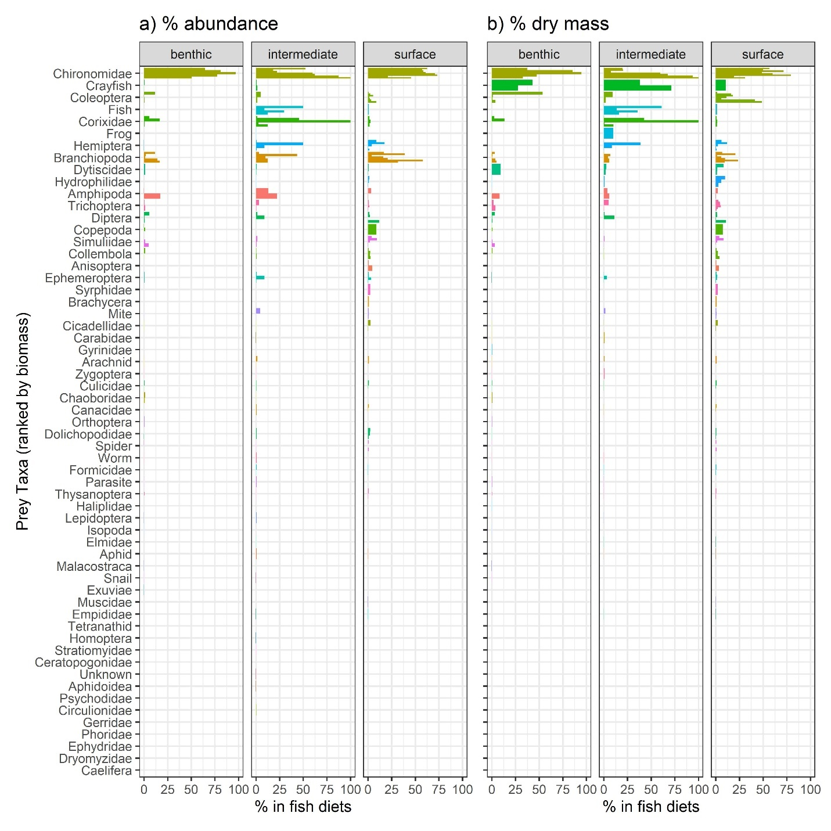

Figure S2. Raw proportion of prey taxa in fish diets by abundance (a) and dry mass (b). Each bar represents a different fish species in one of three foraging domains.

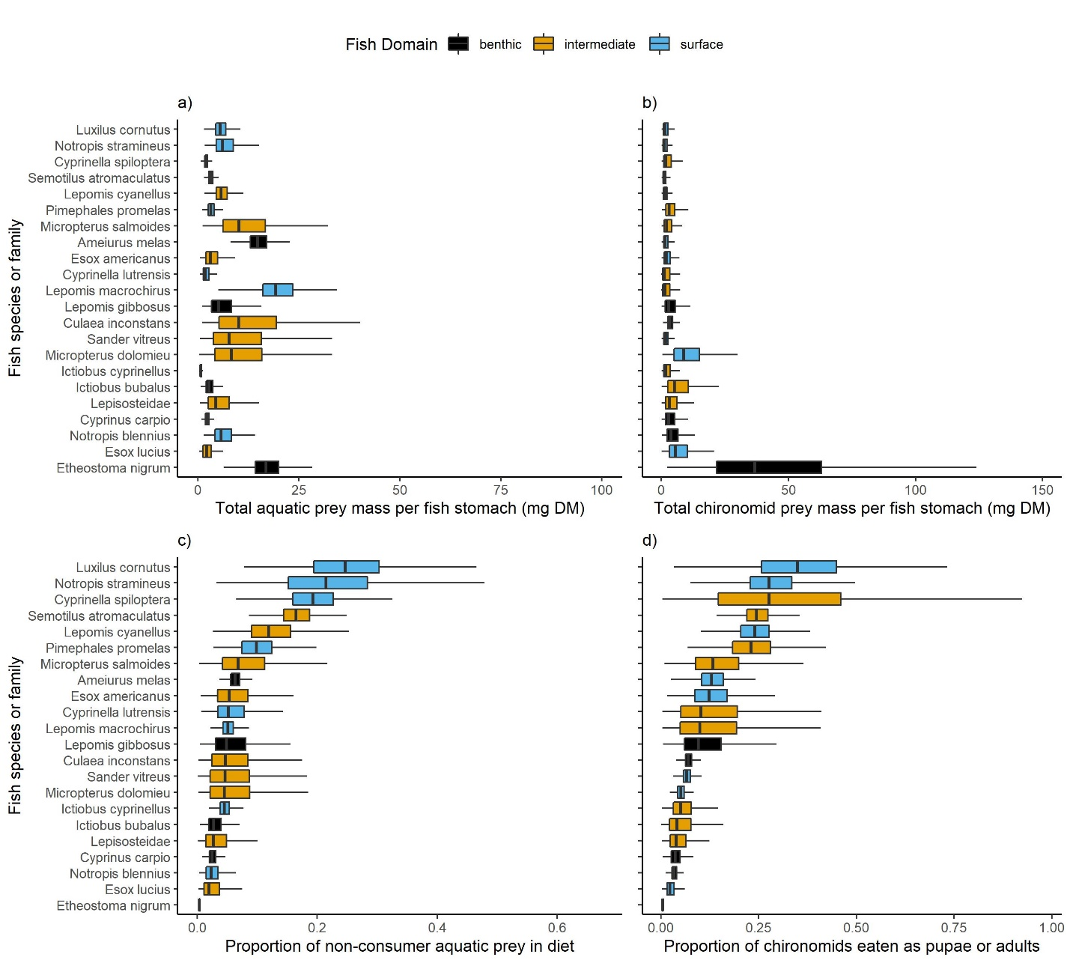

Figure S3. Prey mass (mg DM) per stomach of each fish species for a) total aquatic prey and b) total chironomid prey. The bottom row shows the proportion of all aquatic prey that were eaten as c) non-consumers or d) the proportion of all chironomids that were eaten as adults or pupae. Boxplots show the posterior distribution for each fish species, including the median and interquartile range with lines ranging from the lowest to highest 1.5% posterior quantiles. All panels are sorted by the median proportion of non-consumers in diets.